Last Updated: 1/11/2021
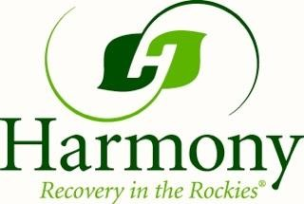
Recovery Coaches
Name | Phone | Email | How they Coach/Gender they coach | Where they live
Dana Daily | 303-725-8639 | dana_424@msn.com | Virtual/In Person/Phone  Women | Arvada, CO
David Huff | 303-552-7742 | drhuff@comcast.net  davidhuffrecoverycoach.com | Virtual  Men | Broomfield, CO
Christine Ronlund | 612-730-8186 | chrisronlund@yahoo.com | Virtual/In Person/Phone  Men and Women | Denver, CO
Jenna Drennen | 303-907-0509 | drennenj@msn.com | Virtual/In Person/Phone  Men and Women | Firestone, CO
Debbie Ann Platts | 303-630-1400 | daplatts1@comcast.net | Virtual/In Person/Phone  Men and Women | Longmont, CO
Erin Fitzpatrick | 303-548-1960 | erinfitzpatrick1968@gmail.com | In Person/Phone  Men and Women | Estes Park, CO
Kelly Felz | 720-745-0561 | kellyfelz@gmail.com | Virtual/In Person/Online  Men and Women | Arvada, CO
Ron Sweetin | 970-776-6355 | wttwphoto@comcast.net | In Person/Phone  Men | Loveland, CO
Sara Broughton | 970-389-4355 | schbroughton@yahoo.com | Virtual/In Person/Online  Men and Women | Frisco, CO

